How to shrink your holiday eco-footprint.
Sara Rubin
Dec 26, 2015

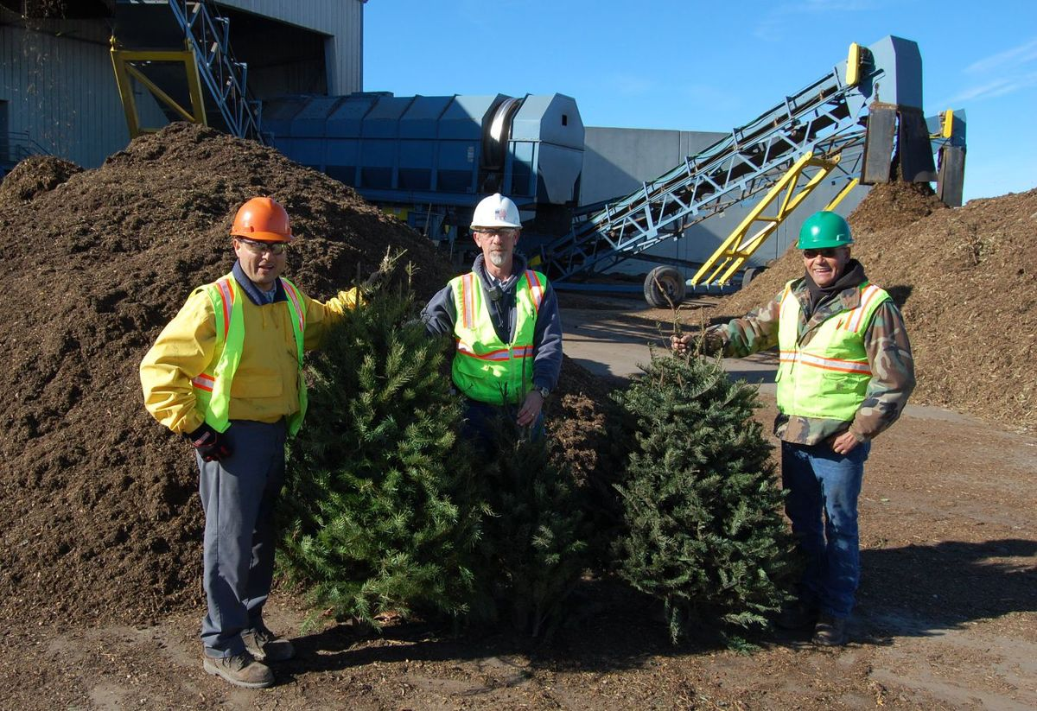
Workers at Monterey Regional Waste Management District stand in
front of a pile of mulched Christmas trees, ready to go into compost.

'Tis the season of indulgence and of gift-giving. It's also the season where we expect to see to a spike in trash, with all the wrapping paper, styrofoam packaging and undesirable white elephant gifts wending their way to the dump.
At Monterey Regional Waste Management District in Marina, December is regularly the biggest trash month of the year, with thousands of Christmas trees and other trash coming in.
Last year, haulers delivered 11,837 tons of material in December, a 7-percent increase over the monthly average. (July, peak tourist and festival season, ranks second.)
The good news is that MRWMD and Salinas Valley Solid Waste Authority offer special holiday services to recycle your garbage.
Both MRWMD and SVSWA chip Christmas trees, and convert the wood chips into compost.
"Those are great ingredients in our compost program," says Jeff Lindenthal, director of community programs at Monterey Regional Waste Management District. "The trees contain nitrogen in the needles and carbon in the wood. Those are the key ingredients."
Another perk: For the month of January, their compost piles smell the best they ever do, "like a tree lot."
To recycle Christmas trees, remove all lights, tinsel and ornaments.
Free drop-off is available at Monterey Regional Waste Management District through the end of January. GreenWaste Recovery, the Monterey Peninsula hauler, offers curbside pick-up through Jan. 15; trees must be cut down to 6-foot lengths.
Free drop-off is available through January at all three Salinas Valley locations, as well: Sun Street Transfer Station, Johnson Canyon Landfill and Jolon Road Transfer Station.
Curbside pick-up is offered for trees 5 feet or smaller through Jan. 29 in King City and unincorporated Monterey County; it's available only through Jan. 22 in Salinas, and Jan. 15 in Gonzales, Greenfield and Soledad.
Also new on the Monterey Peninsula, thanks to the new hauler, GreenWaste: battery pick-up and electronics recycling. You can leave spent batteries in a clear bag on top of the recycling bin, or drop small e-waste (like calculators, phones or keyboards) directly in the bin.
Another new service, which has historically been available only around the holidays, is polystyrene pick-up. Polystyrene, more commonly called styrofoam, is very costly to recycle. To recycle packing peanuts or large blocks of polystyrene commonly used to ship electronics or fragile items, first pack it into a clear plastic bag, then drop that into the recycling bin.
And one more note: Lots of unwanted gifts (as well as artificial Christmas trees) are donated every year to Last Chance Mercantile, the thrift store at MRWMD, at this time of year.

