Education Digest for Dec. 22
Roberto M. Robledo, The Salinas Californian 9:05 p.m. PST December 21, 2015

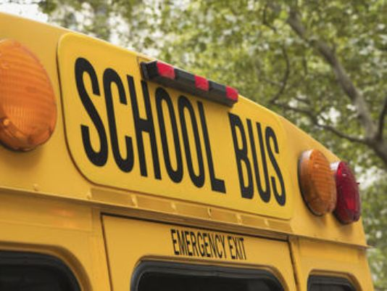
Winter break in on for local schools
Salinas-area school districts are on winter break. Here is a schedule:
- Alisal Union School District, Dec. 21 to Jan. 8; students return Jan. 11.
- North Monterey Co. Unified, Dec. 21 to Jan. 8; students return Jan. 11
- Salinas City, Dec. 21 to Jan. 8; students return Jan. 11.
- Salinas Union High School, Dec. 21 to Jan. 8; students return Jan. 11.
- Santa Rita Union, Dec. 28 to Jan. 8; students return Jan. 11.
- Spreckels Union, Dec. 21 to Jan. 4; students return Jan. 5.
- Washington Union, Dec. 21 to Jan. 4; students return Jan. 5.
- Notre Dame High School, Dec. 21 to Jan. 4; students return Jan. 5.
- Palma High School, Dec. 21 to Jan. 4; students return Jan. 5.
Better attendance focus of bike giveaway
Perfect attendance may win you a bike at Roosevelt School in Salinas. Locally-based Markon Cooperative Inc. is sponsoring a drawing to award bikes as a way to discourage truancy and improve attendance at the elementary school.
Markon is funding six bike giveaways throughout the 2015-16 school year. The first two bikes were awarded at a school assembly Dec. 4, according to a press release.
Nearly the entire student body at Roosevelt comes from socio-economically disadvantaged families. Poverty is associated with high truancy levels and resultant low literacy rates, according to research. About 50 children who attend Roosevelt are absent on a daily basis, officials said.
“Establishing community partnerships is a main goal for our district and schools,” said Roosevelt Principal Linda Barrera. “Through our partnership with Markon, we are able to provide our students with an amazing incentive that not only encourages them to come to school more often, but also serves as a healthy form of entertainment.”
Markon Cooperative, Inc. provides fresh produce purchasing, logistics, information, and marketing services to seven member distributors and their food-service customers. Online: Markon.com.
Writing coaches needed for Youth Authors 2016
The National Steinbeck Center’s Young Authors program is looking for writing coaches for this year’s contest.
The 13th annual event to inspire middle school students to write will be held Monday, March 7, 2016.
Steinbeck Young Authors focuses on John Steinbeck’s novella “The Red Pony.” The program takes place in three stages: a classroom component, a Day of Writing event for finalists and an awards ceremony.
On the Day of Writing, March 7, students will write an essay about their personal life and their reflections on the Red Pony. Students are paired with a writing coach and later judges review the students’ final works.
Coaches should plan to commit three hours to the program. The award ceremony will be held on April 16.
To volunteer, email Marci Bracco Cain marci@chatterboxpublicrelations.com.
Silicon Valley group offering STEM scholarships
Latino students focused on the STEM subjects are eligible for scholarships through the Silicon Valley Community Foundation. This scholarship, established SVCF by the Hispanic Foundation of Silicon Valley, will award up to $30,000 to help 100 Latino students continue their education in science, technology, engineering and math programs. College students including those in the Salinas Valley who are entering their junior or senior year are eligible. Online: For an applications and details, visit: http://www.siliconvalleycf.org/scholarships/latinos-technology-scholarship. Applications will be accepted online starting Jan. 6, 2016.
Waste Management board honors Carmel Unified
Carmel Unified School District has received another honor for its environmental stewartship projects. On Dec. 18, the Monterey Regional Waste Management District Board of Directors presented the district with a resolution recognizing its efforts to help conserve the local lands and marine life. Earlier this year, Carmel Unified became the first school district in the nation to become an Ocean Guardian School District, so named by NOAA, the National Oceanic and Atmospheric Administration. All six district schools have projects under way to recycle, reduce waste, engage in composting – all toward protecting local watersheds, the Monterey Bay National Marine Sanctuary, and the ocean.
The Waste Management board noted Carmel’s focus on the 4 Rs: waste reduction, reuse, recycling, and composting; including the reduction and elimination of single-use plastics, such as water bottles, drinking straws, and food wrappers.
Special kids basketball league begins Jan. 23
Families of children with special needs are invited to join Special Kids Crusade’s REACH Basketball program, which begins Jan. 23. Children and young adults ages 6 to 22 are welcome. Participants will meet for one hour per weekend for six weeks at one of the two Boys & Girls Clubs. The cost is $50 per player. To register online, visit www.SpecialKidsCrusade.org or call 831-372-2730831-372-2730.
REACH Basketball gives children an opportunity to play basketball. Through weekly one-on-one connections with volunteer partners, participants get a chance to develop motor skills, enhance cognitive abilities, and practice socializing with peers and adults. Special Kids Crusade is a nonprofit whose mission is to develop resources, raise awareness and provide support for children with developmental disabilities and their families.
Compiled and edited by Roberto M. Robledo. The Education Digest appears online on Monday and in print each Wednesday. If you have an item for the Education Digest, call 831-754-4269831-754-4269 or email to: rrobledo@thecalifornian.com

